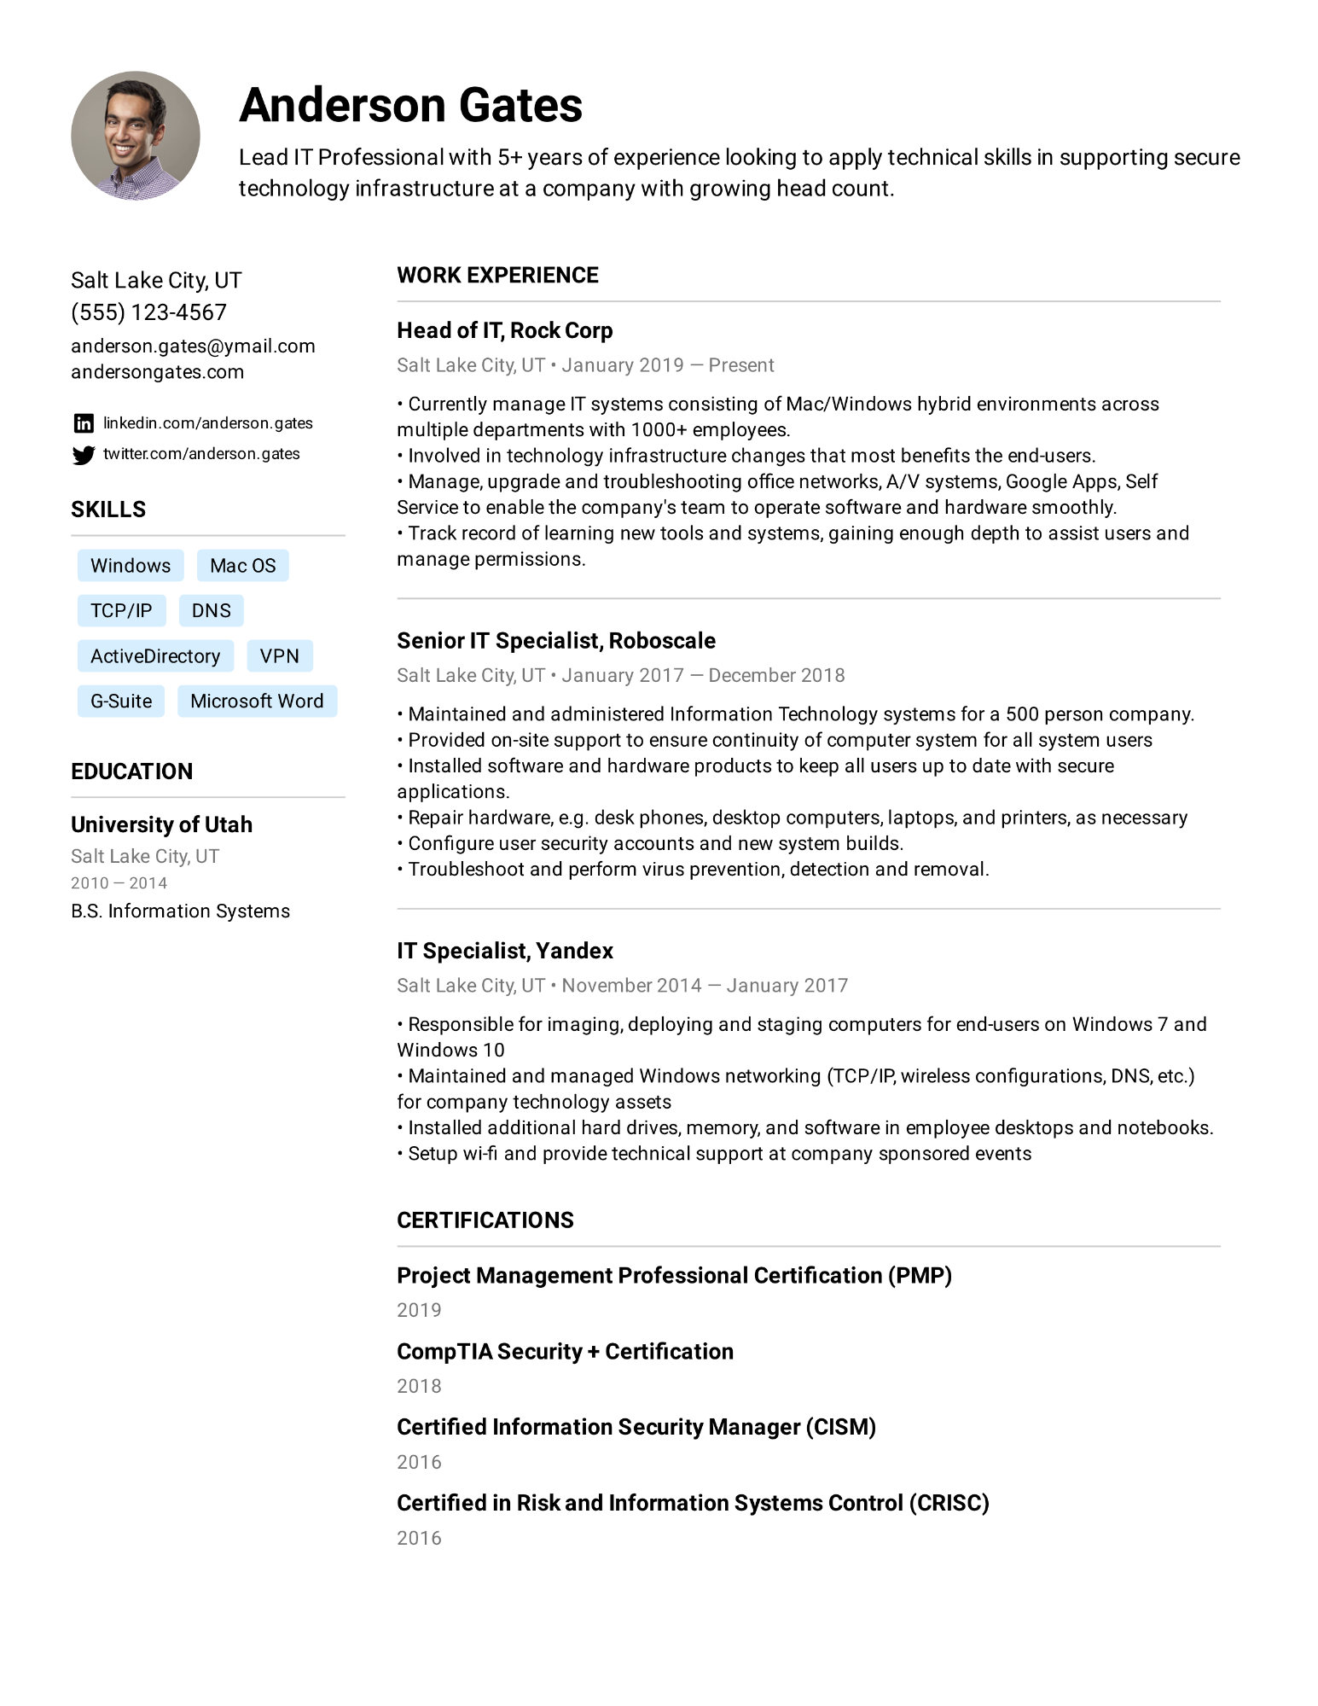
Anderson Gates
Lead IT Professional with 5+ years of experience looking to apply technical skills in supporting secure technology infrastructure at a company with growing head count.
Salt Lake City, UT (555) 123-4567
anderson.gates@ymail.com andersongates.com
in linkedin.com/anderson.gates twitter.com/anderson.gates
SKILLS
WORK EXPERIENCE
•
Head of IT, Rock Corp
Salt Lake City, UT⚫ January 2019 - Present
· Currently manage IT systems consisting of Mac/Windows hybrid environments across multiple departments with 1000+ employees.
• Involved in technology infrastructure changes that most benefits the end-users.
• Manage, upgrade and troubleshooting office networks, A/V systems, Google Apps, Self Service to enable the company's team to operate software and hardware smoothly.
• Track record of learning new tools and systems, gaining enough depth to assist users and manage permissions.
Windows Mac OS
TCP/IP DNS
ActiveDirectory VPN
G-Suite Microsoft Word
EDUCATION
University of Utah
Salt Lake City, UT
2010-2014
B.S. Information Systems
Senior IT Specialist, Roboscale
•
Salt Lake City, UT⚫ January 2017
December 2018
Maintained and administered Information Technology systems for a 500 person company.
• Provided on-site support to ensure continuity of computer system for all system users Installed software and hardware products to keep all users up to date with secure applications.
•
·
Repair hardware, e.g. desk phones, desktop computers, laptops, and printers, as necessary • Configure user security accounts and new system builds.
Troubleshoot and perform virus prevention, detection and removal.
IT Specialist, Yandex
·
Salt Lake City, UT November 2014 - January 2017
• Responsible for imaging, deploying and staging computers for end-users on Windows 7 and Windows 10
• Maintained and managed Windows networking (TCP/IP, wireless configurations, DNS, etc.) for company technology assets
•
Installed additional hard drives, memory, and software in employee desktops and notebooks.
• Setup wi-fi and provide technical support at company sponsored events
CERTIFICATIONS
Project Management Professional Certification (PMP)
2019
CompTIA Security + Certification
2018
Certified Information Security Manager (CISM)
2016
Certified in Risk and Information Systems Control (CRISC)
2016

